MATHEMATICS FOR MACHINE LEARNING

LAB 3– 5%

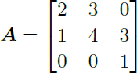Use Python to answer the following questions. Hand in pdf and python file to Dropbox

1. Icon  Description automatically generatedShow that the vector x1 = is an eigenvector of
   1. 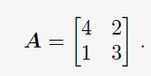What is the eigenvalue of x1?
2. Find all the eigenvalues and eigenvectors for:

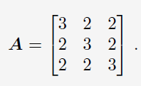

1. Find the eigenspaces for

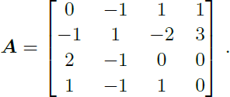

1. Compute all the eigenspaces for

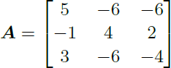

1. Compute the eigenspaces for the matrix



1. Find the determinant and trace of the matrix: